Kansas Medical Assistance Program (KMAP)

KMAP Provider Portal

Pharmacy Billing Packet – 2022

Version 1.0

Table of Contents

1 Introduction 1

2 Billing Options Internet 2

3 KMAP Home Page 3

4 KMAP Provider Portal Home Page 4

5 Submit Pharmacy Claim 8

5.1 Provider Information 10

5.2 Patient Information 11

5.3 Claim Information 12

5.4 Pricing Information Submitted 14

5.5 DUR Override Code Information 15

5.6 Diagnosis Information 16

5.7 Review Claim 17

5.8 Submit Claim 18

6 Claim Inquiry 20

6.1.1 Copy Claim 24

6.1.2 Save As Template 25

7 Paper Billing CMS 1500 26

7.1.1 Billing Instructions 27

List of Figures

Figure 1: KMAP Home Page 3

Figure 2: Provider Portal Home Page 4

Figure 3: Secure Login Page 4

Figure 4: Username 5

Figure 5: Password 5

Figure 6: Challenge Question 6

Figure 7: Successful Login – KMAP Provider Portal Home Page 7

Figure 8: My Home Page 8

Figure 9: Submit Pharmacy Claim 9

Figure 10: Provider Information 10

Figure 11: Patient Information 11

Figure 12: Claim Information 13

Figure 13: Pricing Information Submitted 14

Figure 14: DUR Override Code Information 15

Figure 15: New Diagnosis Code 15

Figure 16: Diagnosis Information 16

Figure 17: New Service Line 16

Figure 18: Review Claim 17

Figure 19: Submit Claim 18

Figure 20: Pharmacy Claim Receipt 19

Figure 21: My Home Page 20

Figure 22: Search Claims 21

Figure 23: Search Claims – Search Results 21

Figure 24: Pharmacy Claim 22

Figure 25: Claim Options 23

Figure 26: Copy Pharmacy Claim 24

Figure 27: New Template 25

Figure 28: Paper Claim 32

# Introduction

The Kansas Medical Assistance Program (KMAP) offers different billing options to all providers. These options are:

* KMAP Provider Portal
* Paper billing

These options give providers different channels for their specific office needs. Each option has its own benefits.

**KMAP Web site**

* Free
* Fast
* Secure
* Fast response on claim status
* High quality of data

**Paper Billing**

* Claim form ordering (not supplied by KMAP)
* No front end editing
* Usually used by providers if they have no Internet access or if submitting timely filing, adjustments, or claims requiring attachments, i.e., sterilizations

Provider Electronic Solution (PES) is another free billing option offered by KMAP for more information about this billing service please contact Customer Service for more information and training.

# Billing Options Internet

Services provided on the KMAP Provider portal are free of charge.

Effective June 15, 2022, Internet Explorer, including version 11, will no longer be supported by Microsoft. Therefore, the Kansas Medical Assistance Program (KMAP) online services will no longer be able to support Internet Explorer, including version 11. If Internet Explorer is used, the new Kansas Modular Medicaid System (KMMS) and the new KMAP portals may not operate as expected. Organizations should plan accordingly to meet browser requirements.

For optimal performance, please use one of the minimum recommended web browsers listed below:

* Google Chrome (version 85.0.4183.121 or later)
* Microsoft Edge (version 87.0.664.75 or later)
* Mozilla Firefox (version 81.0 or later)

**Important Note:**

When logging in to the application for the first time, you will be asked if you are using a personal or a public computer. Please use caution while answering this question as the privacy and security required to protect the healthcare data could be impacted by your selection.

# KMAP Home Page

The link to access the KMAP Home Page is: <https://portal.kmap-state-ks.us/PublicPage/>

1. KMAP Home Page

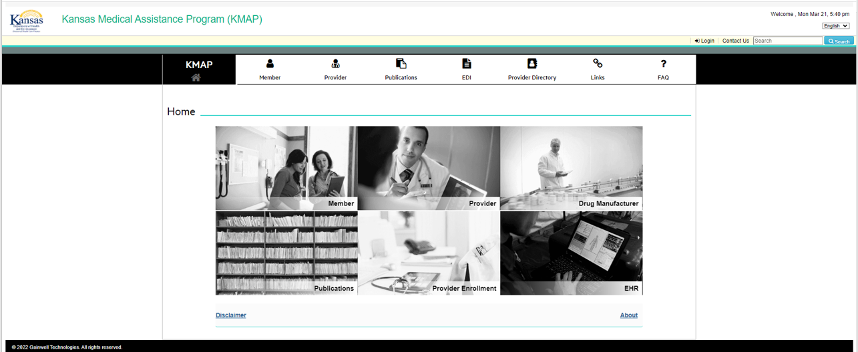

# KMAP Provider Portal Home Page

From the **Provider Portal Home** page follow these steps to access the Secure Web Site: <https://portal.kmap-state-ks.us/SecurePage>.

1. Hover over **Provider**.
2. Select **Provider Login**.
3. Provider Portal Home Page

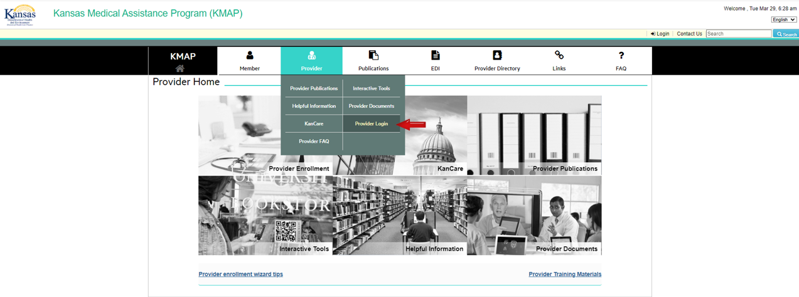

The system returns the **Kansas Medical Assistance Program (KMAP)** secure login page.

1. Click **Login**.
2. Secure Login Page

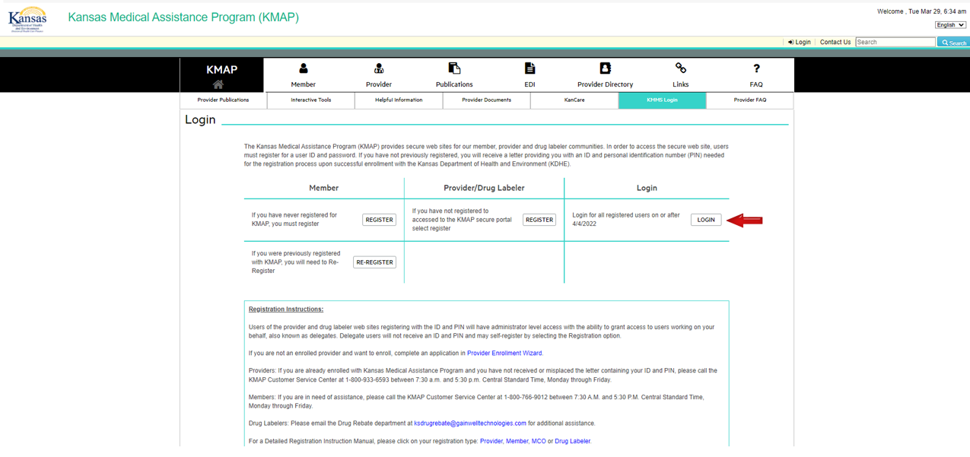

Complete these steps to login to the **KMAP Provider Portal**:

1. Enter your **User Name**.
2. Click **Continue**.
3. Username

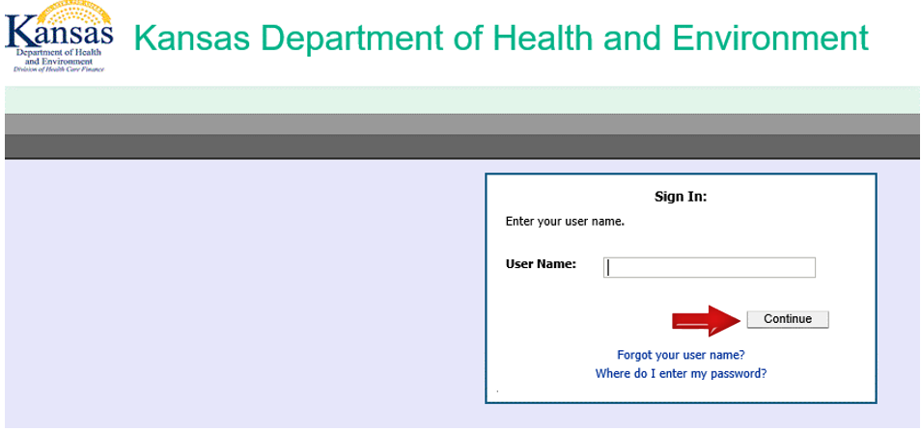

1. Enter your **Password**.
2. Click **enter**.
3. Password

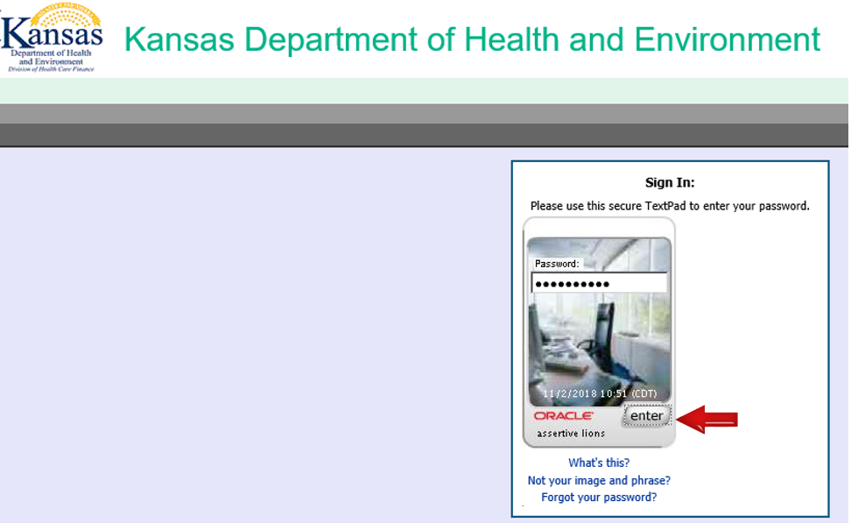

On occasion, you will be asked to answer a challenge question when logging into the system.

1. Answer the **Challenge Question**.
2. Click **enter**.
3. Challenge Question

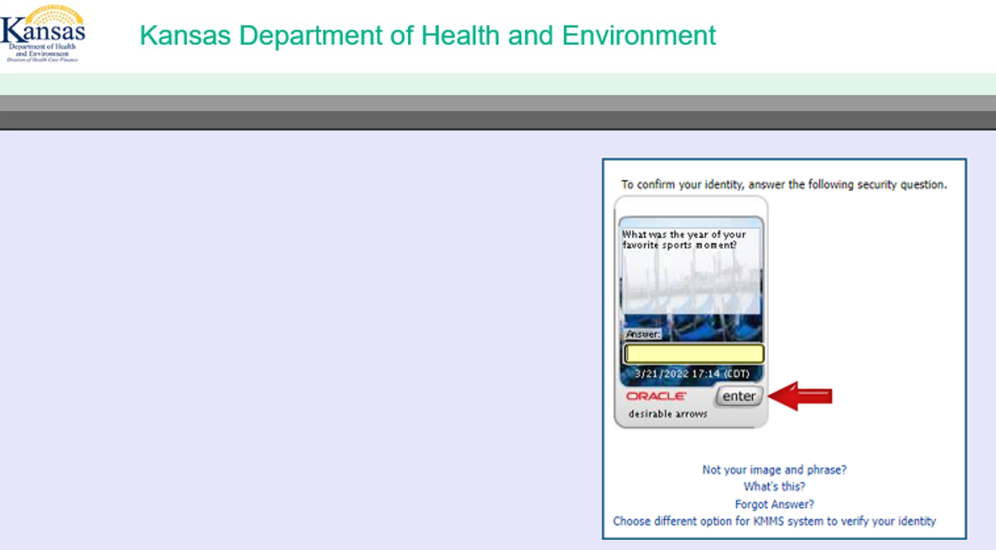

You have successfully logged into the **KMAP Provider Portal Home Page**.

The main **Provider** menu appears after you log on and view your global messages.

Here, you can click any of the links on the window to access the corresponding pages.

If you are associated with more than one provider, you have the option to switch Providers using the Switch Providers link. If you are associated to multiple providers, it is very important to validate which provider you are working under when submitting claims. Submitting claims under the wrong provider could result in denied claims.

You can elect to download the Remittance Advice which is available the first Monday immediately following the previous Friday’s claim processing deadline.

1. Successful Login – KMAP Provider Portal Home Page

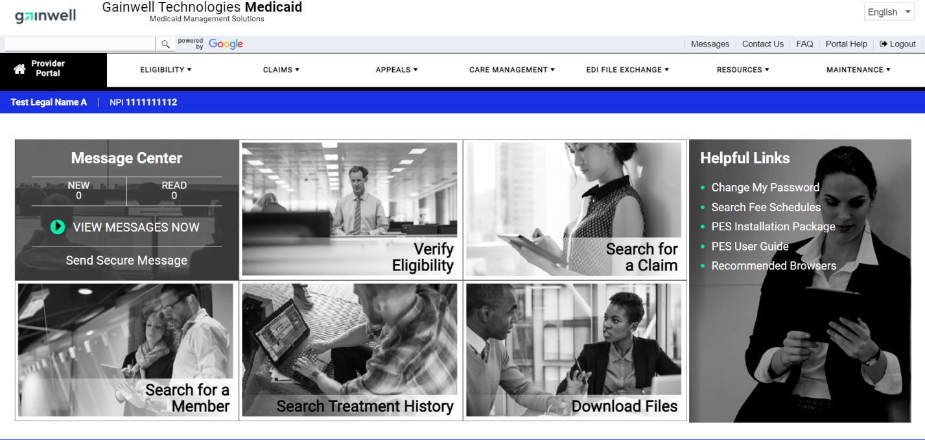

# Submit Pharmacy Claim

Complete these steps to submit a **Pharmacy Claim**:

1. Hover over **CLAIMS**.
2. Select **Submit Pharmacy Claim**.
3. My Home Page

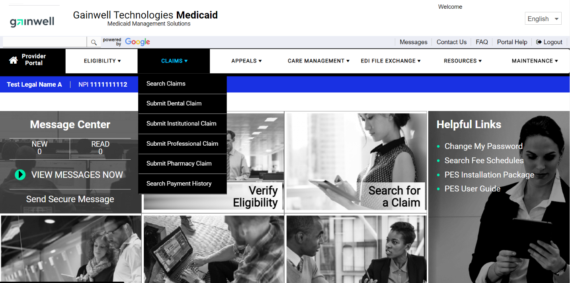

The **Kansas Medical Assistance Program** is following the guidelines set up by CMS to use HIPAA Compliant Claim Adjustment Reason Codes (CARC) and Remittance Advice Reason Codes (RARC) codes at the detail level.

1. Submit Pharmacy Claim

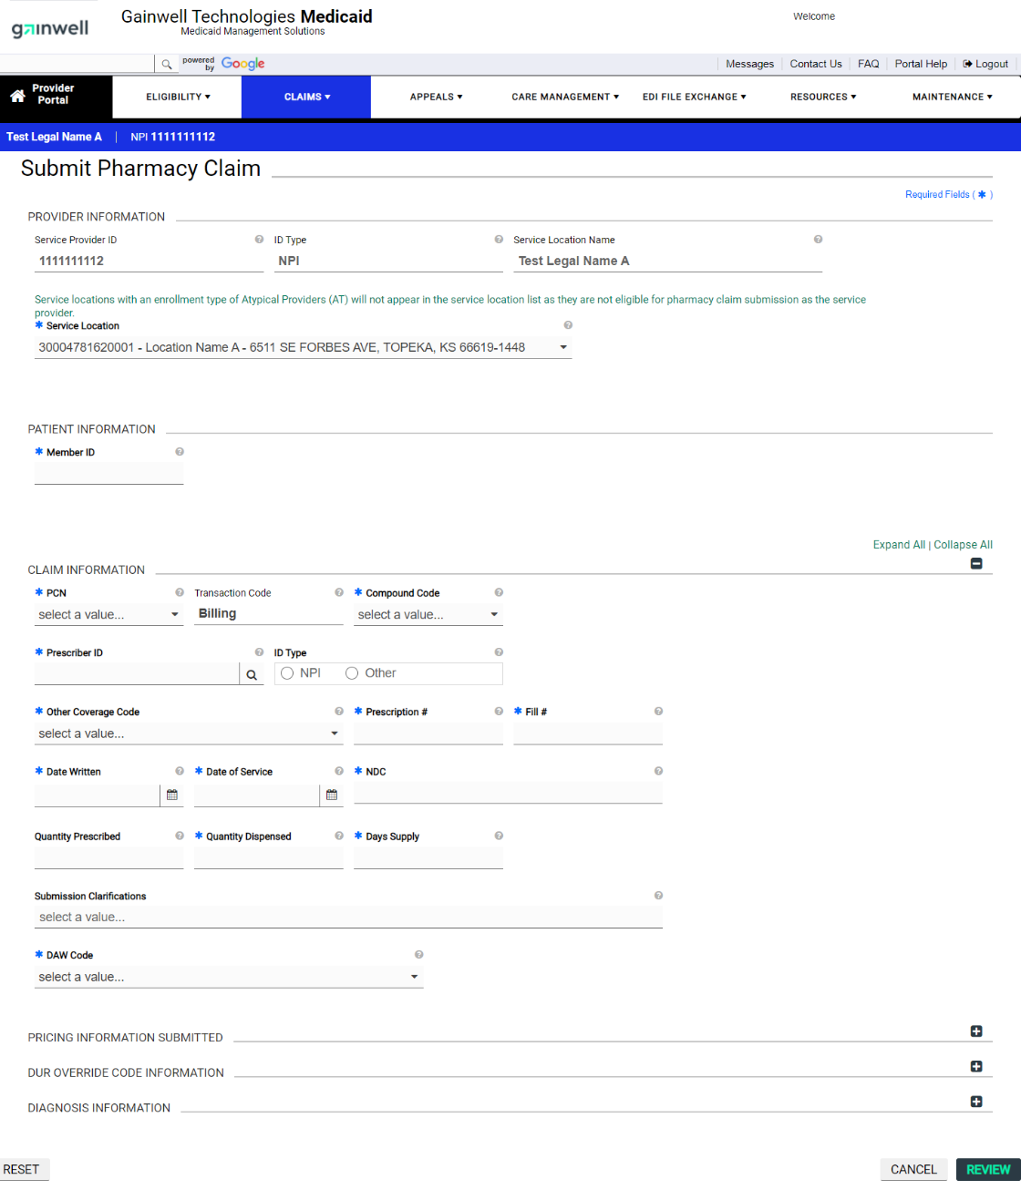

## Provider Information

Complete these fields to file a **Pharmacy Claim** from the **KMAP Provider Portal**.

* **Billing Provider ID** –Billing Provider’s ID. This field auto-populates based on the user.
* **ID Type** –Provider’s ID type. This field auto-populates based on the user.
* **Service Location Name** – Service location name. This field auto-populates based on the user.
* **Service Location** – Service location of the provider, including service location ID, name, and address. If there is only one location, the information will auto-populate.

1. Provider Information

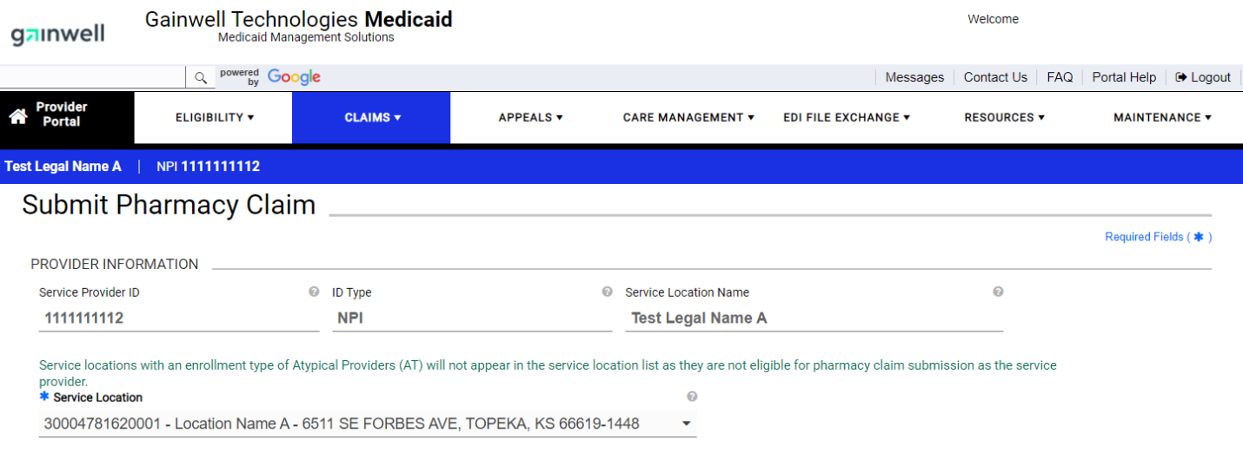

## Patient Information

The **Patient Information** section initially consists of the **Member ID** field. When entered, the member information is retrieved from the system and is displayed, as shown in the following figure.

Complete the **Patient Information** field.

* **Member ID** – Member’s identification number.
* **Pregnancy Indicator (optional)** – Indicates whether the member is pregnant.

1. Patient Information

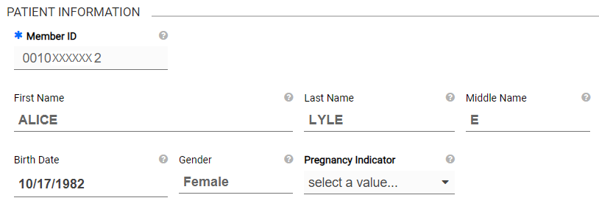

## Claim Information

Complete these fields to enter **Claim Information**.

* **PCN** – A type of pharmacy claim, (Drug, Crossover, or Encounter) for processing prescription drug claims.
* **Transaction Code (optional)** – Specifies the type of transaction.
* **Compound Code** – Indicates if the drugs on the claim are Compound or Not a Compound.
* **Prescriber ID** – Prescriber’s identification Number.
* **ID Type (optional)** – Provider’s ID Type. This field auto-populates based on the Prescriber ID entered.
* **Other Coverage Code** – Code indicating whether or not the patient has other insurance coverage.
* **Prescription #** - Prescription number.
* **Fill #** - Specifies the type of transaction
* **Date Written** – Date the prescription was written in MM/DD/YYYY format.
* **Date of Service** – Service date in MM/DD/YYYY format.
* **NDC** – National drug code is a Universal product identifier for the medication prescribed.
* **Quantity Prescribed (optional)** – Specifies the quantity of the drug prescribed.
* **Quantity Dispensed** – Specifies the quantity of the drug dispensed.
* **Days Supply** – Duration of the prescription supply.
* **Submission Clarifications (optional)** – Specifies the additional clarifications for the submission.
* **DAW Code** – DAW (Dispense as Written) specifies how the drug was dispensed by the pharmacy.

1. Claim Information

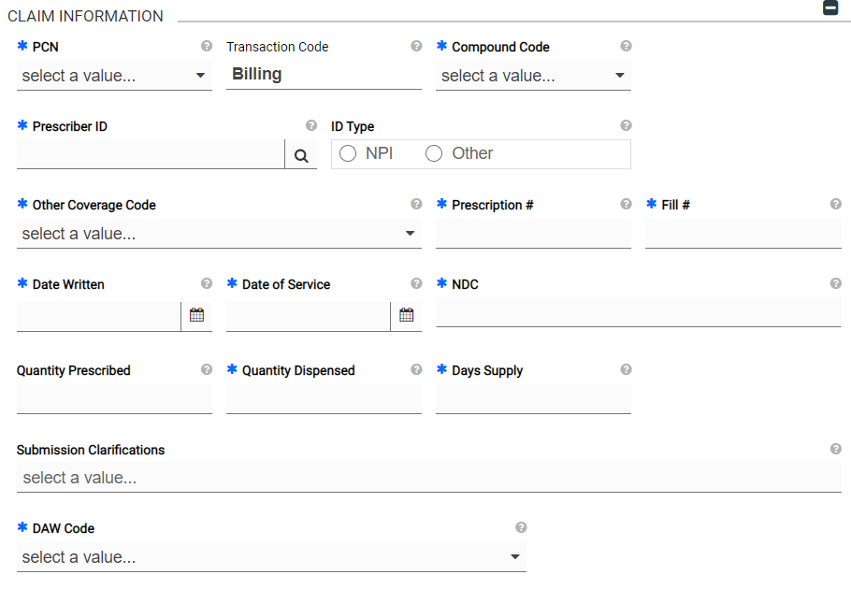

## Pricing Information Submitted

Complete these fields to add pricing information.

* **Usual & Customary Charge** – Specifies the amount paid for a service in a geographic area based on what providers in the area usually charge for the same or similar service.
* **Ingredient Cost** – Specifies the cost of the ingredient.
* **Basis of Cost Determination** – Specifies the basis by which the ingredient cost is determined.
* **Dispensing Fee** – Specifies the cost for dispensing the drug.
* **Incentive amount (optional)** – Specifies the amount the pharmacy is seeking for reimbursement to administer the product.
* **Gross Amount Due** – Specifies the total cost associated with the prescription.

1. Pricing Information Submitted

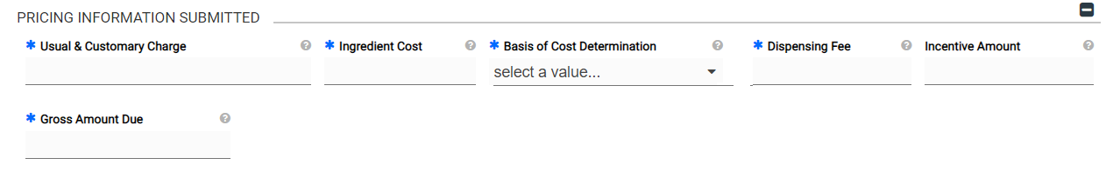

## DUR Override Code Information

Complete these fields to add **DUR Override Code** information to the claim.

* **CREATE NEW**

1. DUR Override Code Information

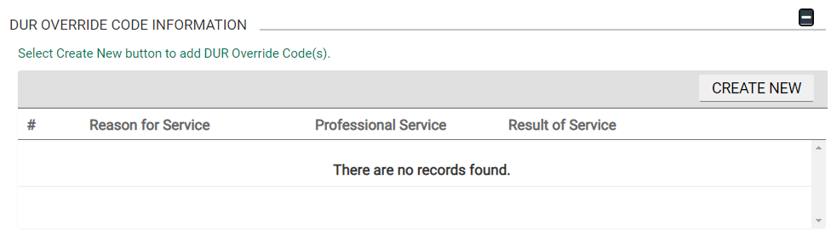

Complete these fields to add new **DUR Override Code** information.

* **Reason for Service** – Specifies the reason for service for the prescription.
* **Professional Service** – Specifies the professional service determined by the pharmacist after consulting with the member.
* **Result of Service** – Specifies the result of a professional service.
* **ADD & CLOSE** – add new diagnosis code and close the overlay
  + **RESET** – clears the fields to default value
  + **CANCEL** – closes the overlay without saving the information

1. New Diagnosis Code

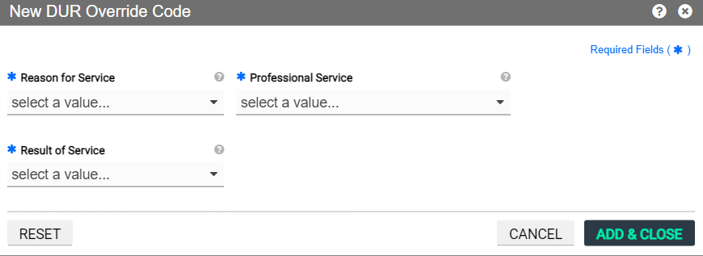

## Diagnosis Information

Complete these steps to add diagnosis information to the claim.

* **CREATE NEW**

1. Diagnosis Information

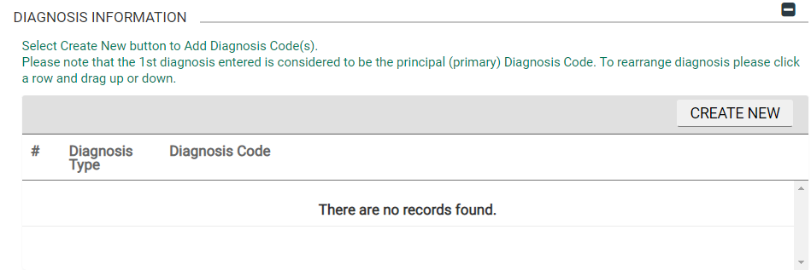

Complete these fields to add a new diagnosis code to the claim.

* **Diagnosis Type** – Specifies the version of the International Classification of Diseases code.
* **Diagnosis Code** – Specifies the diagnosis of the patient.
* **ADD & CLOSE**
  + **RESET** – clears the fields to default value
  + **CANCEL** – closes the overlay without saving the information
  + **ADD ANOTHER** – click to add another new diagnosis code

1. New Service Line

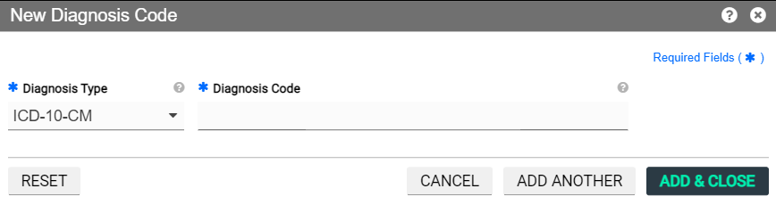

## Review Claim

Review the claim.

* **REVIEW**

1. Review Claim

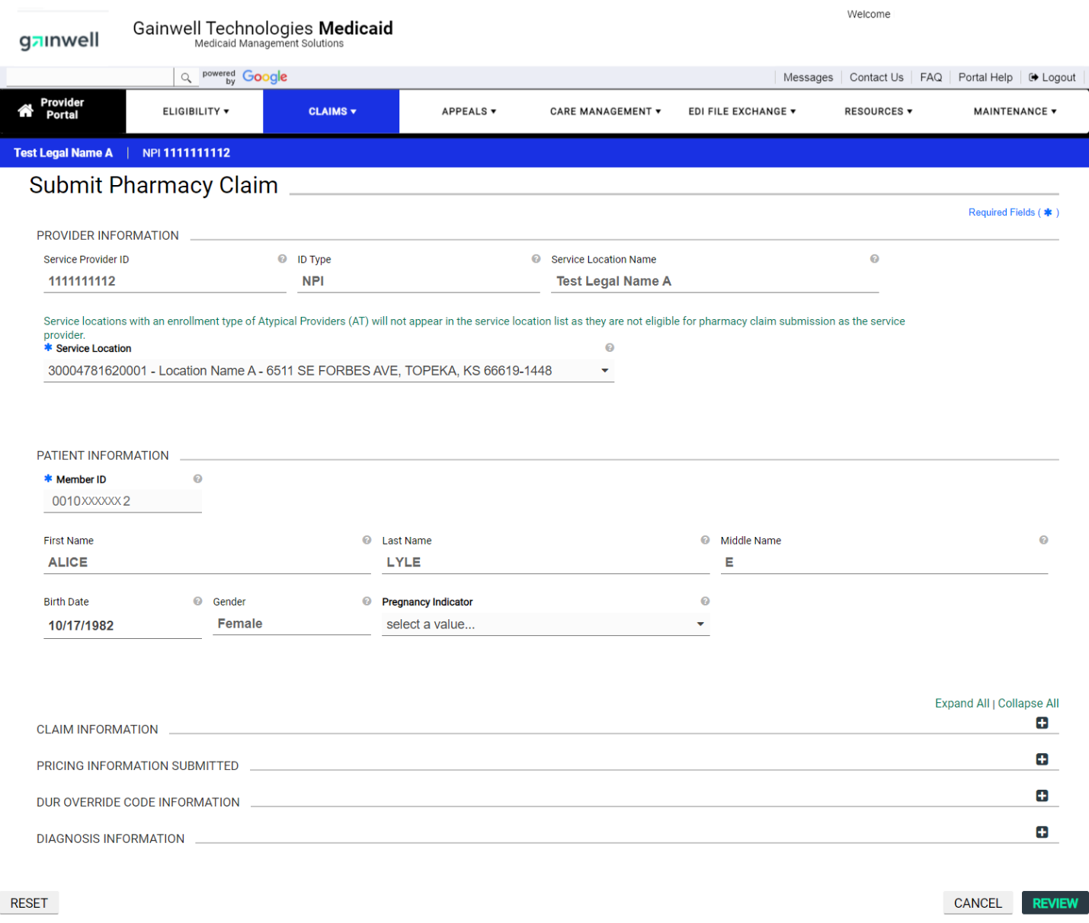

## Submit Claim

Submit the claim.

* **SUBMIT**

1. Submit Claim

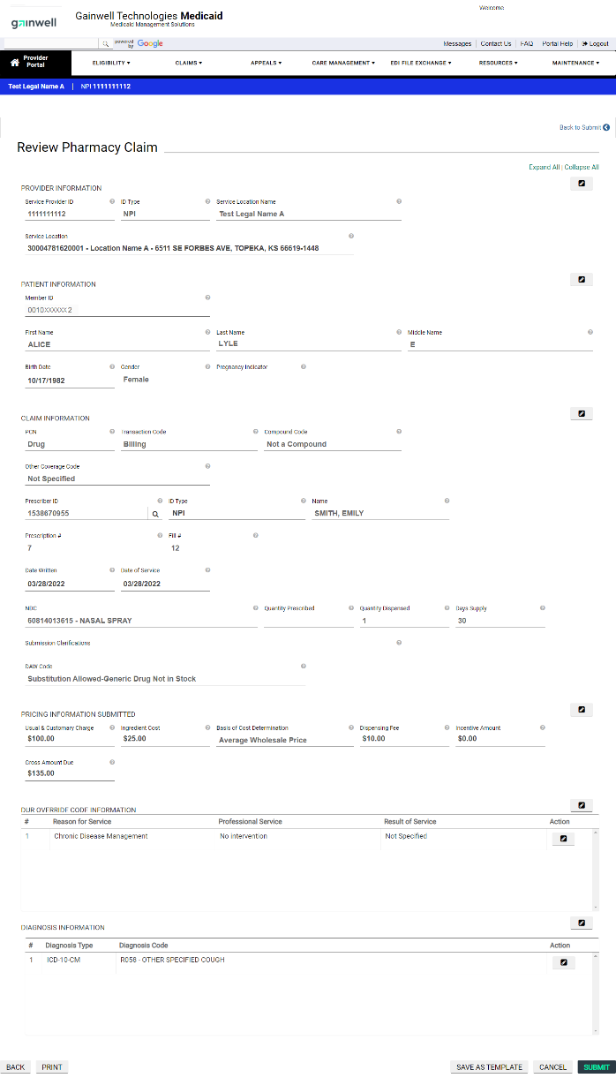

* **PRINT SUMMARY** – print a summary of the current claim.
* **PRINT RECEIPT** – print a copy of the claim receipt.
* **COPY** – copy the current claim.
* **NEW** – start a new claim.
* **VIEW** – view a copy of the current claim.
* **FINISH** – accept and close the claim.

1. Pharmacy Claim Receipt

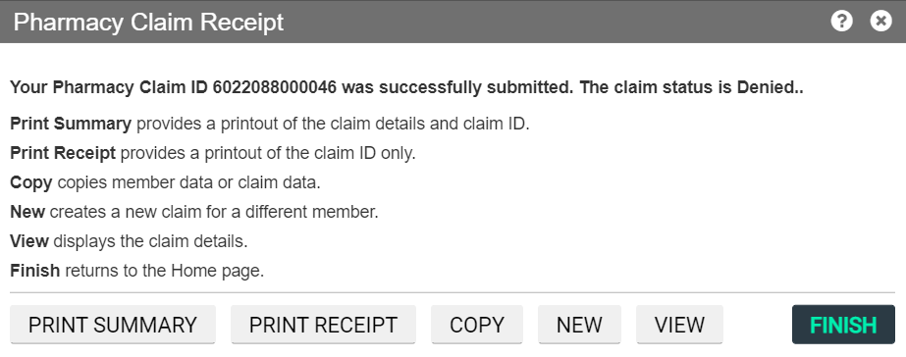

# Claim Inquiry

Complete these steps to search for an existing claim.

1. Hover over **CLAIMS**.
2. Select **Search Claims**.
3. My Home Page



The system returns the **Search Claims** page.

1. Enter one of the following search criteria.
   * **Member ID** – Member’s identification number
   * **Patient Number** – The unique identifier for a patient in the billing submitter’s patient management system.
   * **Claim ID** – Claim identification number.
   * **Date of Service** – Service rendered date in MM/DD/YYYY format.
   * **Paid Date** – Paid date in MM/DD/YYYY format.
   * **Service Location** – Service location of the provider including Service Location ID, Name, and Address.
2. Click **SEARCH**.
3. Search Claims

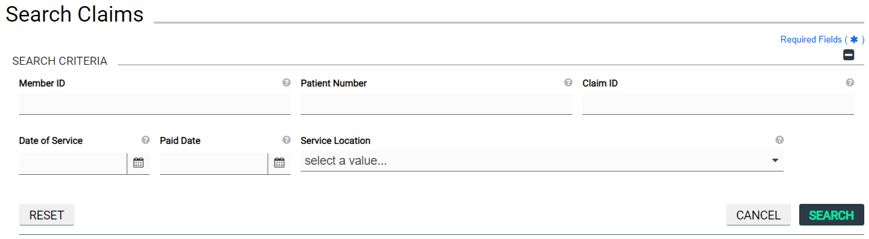

From here, select the row to view claim details.

1. Search Claims – Search Results

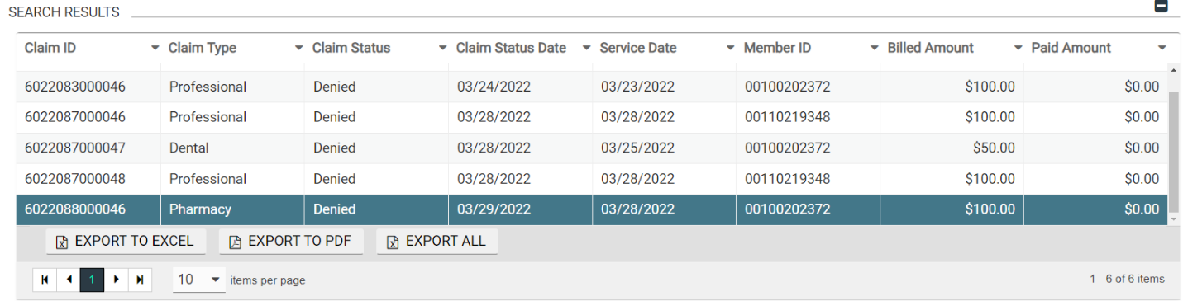

Once you have selected the claim to view the system returns the detail of the claim. As shown in the following figure:

1. Pharmacy Claim

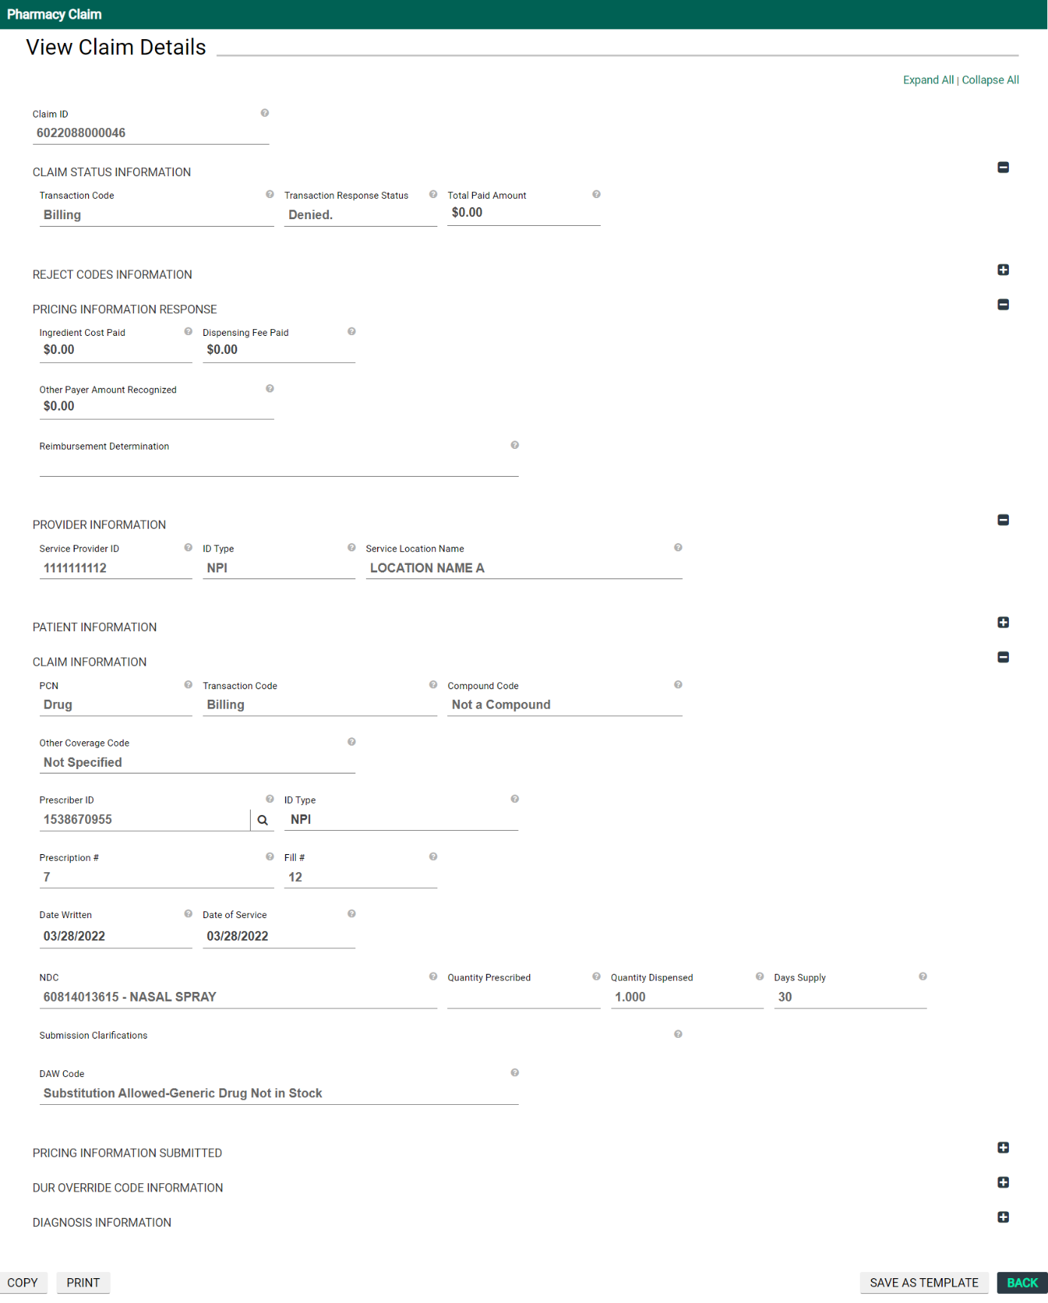

Additional options for the claim inquiry.

* **COPY** – copy the claim or portions of the claim
* **PRINT** – print the claim
* **SAVE AS TEMPLATE** – save the claim as a new template
* **BACK** – return to the previous page

1. Claim Options

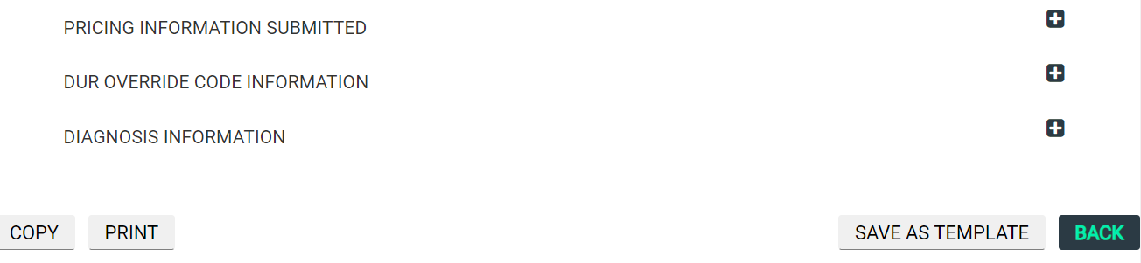

### Copy Claim

Copy Claim – Useful tool for recurring billing

* **Entire Claim** – select this checkbox to copy the entire claim data
* **Service Information** – select this check box to copy the service information from this claim
* **Member Information** – select this check box to copy the member information from this claim
* **Copy** – copy the claim
* **Cancel** – close the overlay without copying the claim

1. Copy Pharmacy Claim

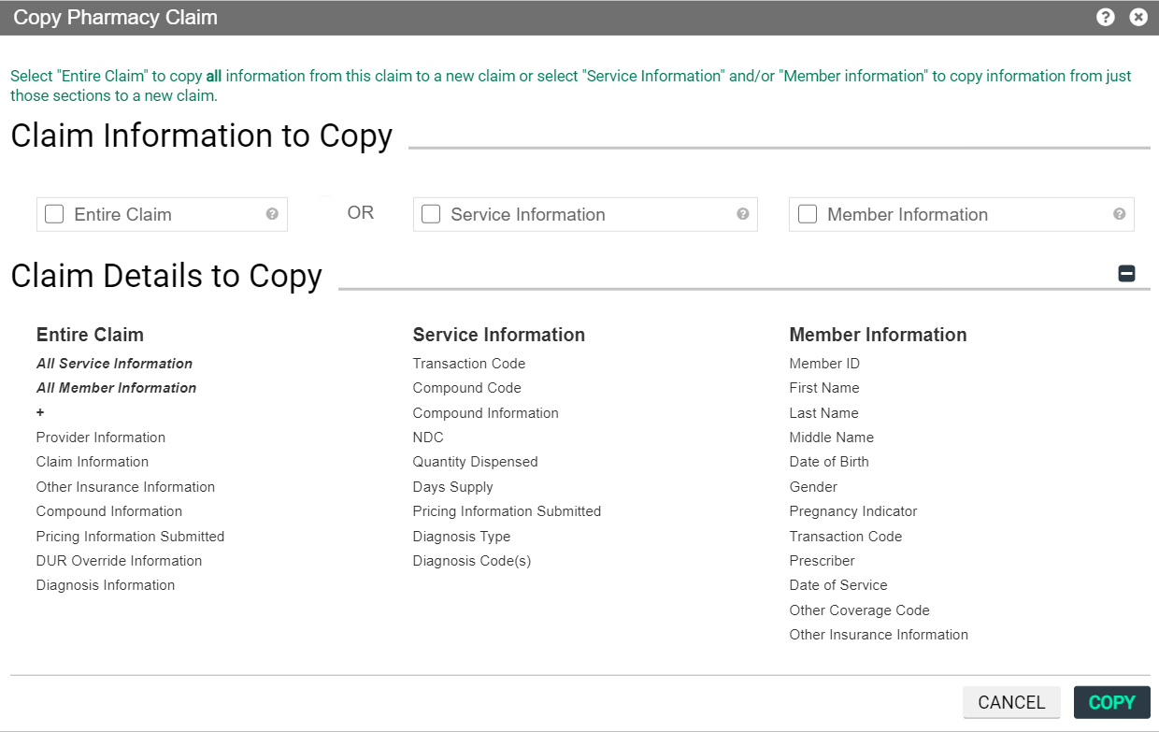

### Save As Template

Please note that saved templates are not shared between providers and their delegates. Any fields can be edited in the template.

* **Template Name** – name of the template being saved
* **Template Description (optional)** – description of the template being saved
* **ADD & CLOSE** – add as template and close the overlay
  + **RESET** – clears the fields to default value
  + **CANCEL** – closes the overlay without saving the information

1. New Template

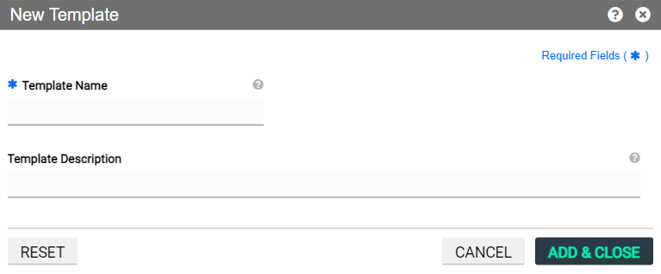

# Paper Billing CMS 1500

Pharmacy providers must use the Pharmacy Claim Form when requesting payment for items provided under KMAP (unless submitting electronically). The Kansas MMIS will be using electronic imaging and optical character recognition (OCR) equipment. Therefore, information will not be recognized if not submitted in the correct fields as instructed.

For paper claim submissions for compounds, bill only one compound prescription per paper claim; do not mix compound claims with noncompound claims. See the special instructions for compound drug claims following the regular instructions.

**Paper Claims – Helpful Tips**

**Paper claim submission address**

Kansas Medical Assistance Program

Office of the Fiscal Agent

PO Box 3571

Topeka, KS 66601-3571

**Tips for faster processing**

* Type the information and use a font that is easy to read.
* Use black or blue ink only.
* Use an original red claim form.
* Do not print information outside of the appropriate field.
* Put comments only in the Comments field.
* Do not staple attachments to claim – use paperclips.

***Note:*** When the fiscal agent receives a paper claim, it is scanned and sent for processing. If the scanner reads it without detecting errors, the claim is immediately sent for processing. If the scanner cannot read a portion or the entire claim, it must be keyed manually.

### Billing Instructions

The following numbered fields are to be completed when required or if applicable.

***NOTE:* For all fields requiring a National Provider Identifier (NPI), the associated provider must be enrolled with KMAP and have a valid NPI on file for the claim to be considered for payment. Reference Section 2000 of the *General Benefits Fee-for-Service Provider Manual*.**

***NOTE:* Fields with an * are not required for fee-for-service Medicaid claims.**

**Completing the Pharmacy Paper Claim Form**

Field 1 **BENEFICIARY LAST NAME**

Enter beneficiary's last name.

Field 2 **FIRST NAME**

Enter first three characters of the beneficiary's first name.

Field 3 **BENEFICIARY IDENTIFICATION NUMBER**

Enter the 11-digit number from beneficiary's State of Kansas Medical Card. DO NOT RECORD THE PROGRAM NUMBER.

Field 4 **NURSING HOME**

If appropriate, enter the correct indicator:

Y = Yes

N = No

Field 5 **KAN BE HEALTHY**

Leave blank (automated).

Field 6 **OTHER** **INSURANCE**

This field represents insurance information. Valid entries in this field are:

Y = If the beneficiary has other health insurance *Note: Indicate the amount paid in Field 16 (Remarks).*

N = No other insurance

X = Insurance denied

R = No response from insurance

Field 7 **PRESCRIPTION NUMBER**

Enter the seven-digit prescription number assigned by the pharmacy.

Field 8 **PRESCRIBING PHYSICIAN MEDICAID NUMBER**

KMAP requires pharmacy providers to submit the prescribing provider’s unique national provider identifier (NPI).

Field 9 **DATE DISPENSED**

Enter the date the drug was dispensed in MM/DD/YY format.

Field 10 **NATIONAL DRUG CODE**

Enter the 11-digit national drug code (NDC) number assigned to the product dispensed. (The last two digits of the NDC number are indicative of package size.) **It is critical that each claim reflects the NDC that appears on the drug package being dispensed**.

NDCs must be given in standard 11-digit format. In cases where the NDC has only three digits in the "product" section (center digits), it is necessary to fill this field to four digits by preceding the three digits with a zero.

Field 11 **REFILL CODE**

Enter the number of times the prescription has been filled. Enter "00" for original and "01" through "99" for refills.

Field 12 **METIRC QUANTITY**

Enter number of tablets or capsules dispensed, number of grams of ointments or powders, or number of ccs of liquids. Rounding up to the nearest whole number will not be accepted. The actual decimal amount must be entered.

Do not insert descriptive designations such as "ccs," "gm," or "each".

Field 13 **DAYS SUPPLY**

Estimate in days the duration of this prescription supply.

Field 14 **DIAGNOSIS/REFERENCE**

For allowable diagnosis codes and coverage information, see each drug/drug class in the *Drug Benefit Limitations* portion of Section 8400 in the Pharmacy Provider Manual. The drugs are not covered for diagnoses other than what   
is specified.

When diagnosis is applicable, the pharmacy will need to contact the prescribing provider if no diagnosis is noted on the prescription. The pharmacy must maintain documentation of physician-supplied diagnosis and contact information in the prescription records.

Field 15 **TOTAL CHARGE**

This field represents the usual and customarytotal charge of the item billed. This amount should always reflect the usual and customary total charge. When a claim is submitted to a third-party payer and payment is received, submit to KMAP the same charge that was submitted to the insurance carrier.

Field 16 **REMARKS**

When adding a remark, identify the line number of the claim that corresponds to the remark. (The Line field is on the left-hand side of the Pharmacy Claim Form.)

This field is used to:

* Indicate insurance carrier and the payment made. (When listing the insurance payments in this field, use the same number as designated in the beneficiary field to indicate the claim that goes with the payment.)
* Enter the original ICN number from previously submitted claims being resubmitted, if applicable.
* Enter the approved prior authorization number, if applicable.
* Identify which lines are part of a compound drug. For each claim (line) that is to process as a compound, the word “compound” is to be clearly written. It is helpful to state which claims (lines) belong to the same compound. For example, "Lines 00-03 are part of the   
  same compound."
* Enter a Submission Clarification Code Value, if applicable. For example, write Submission Clarification Code: XX.

Field 17 **TOTAL BILLED AMOUNT**

Total of detail line items billed.

Field 19 **PROVIDER NAME AND NUMBER**

Enter the name, address, and NPI or 10-digit Medicaid provider number of the billing provider.

Field 20 **SIGNATURE**

Read statement on claim form and sign.

Phrase "signature on file" is acceptable.

Provider’s name typed or stamped is acceptable.

Field 21 **DATE**

Enter the date the form was signed.

**Compound Drug Claims**

* Compound drug claims may be submitted on the Pharmacy Claim Form or via POS (online). Only one dispensing fee will be allowed per compound. Only one copayment fee will be assessed (if applicable) per compound. The first NDC entered for a compound will be considered the primary ingredient. If any NDC in the compound is not covered, the entire compound will deny. Providers may resubmit the compound without the noncovered NDC(s). Claims identified as a compound, but which contain only one ingredient will not be allowed a dispensing fee. If billing for a single NDC compound, do not identify the claim as a compound.
* For compound submissions using the paper Pharmacy Claim Form, use the following steps: Enter each NDC making up the compound as a single line, starting with the NDC considered to be the primary ingredient. If you are submitting more than 10 lines (NDCs) for the same compound, staple the paper claim forms together and note which NDC is the primary ingredient.

***Fields 1-11***: Complete the same as for any pharmacy claim.   
***Note:******Field 7*** (Rx number) will be the same for all lines within the same compound.

***Field 12***: Enter the metric quantity for the NDC on this individual line only not the total quantity for the entire compound.

***Fields 13-14***: Complete the same as for any pharmacy claim.

***Field 15***: Enter the charge for the NDC on this individual line only not the total quantity for the entire compound. The charge for the primary (first) ingredient should include a dispensing fee in addition to the drug cost.

***Field 16***: If both of the following conditions apply, be sure to separate these in this field.

* For each claim (line) that is to process as a compound, the word “Compound” is to be clearly written. It is helpful to state which claims (lines) belong to the same compound. For example, "Lines 00-03 are part of the same compound."
* For a compound where the primary insurance has made a payment, the line number(s) must be indicated along with the insurance carrier and payment made. Remember to mark Field 6 accordingly.

***Fields 17-21*:** Complete the same as for any pharmacy claim.

***Note:*** *For paper claim submissions for compounds, bill only one compound prescription per paper claim; do not mix compound claims with noncompound claims.*

**SUBMISSION OF CLAIM**

Send completed claim to:

Office of the Fiscal Agent

P.O. Box 3571

Topeka, Kansas 66601-3571

Copies of the Pharmacy Claim Form can be ordered through the fiscal agent. Refer to Section 1100 in the *General Introduction Manual*.

Pharmacy providers can contact the pharmacy help desk toll-free number for assistance with pharmacy claims questions at 1-866-405-5200.